**“**SMART ATTENDANCE MARKING SYSTEM USING FACE RECOGNITION**”**

*Project report submitted in partial fulfilment of the requirement for the degree of*

*Bachelor of Technology*

**IN**

**Computer Science and Engineering**

By

**Abhinav Sharma (171297)**

**Tarun Kumar Sharma (171325)**

UNDER THE SUPERVISION OF

**Dr. Ruchi Verma**

**Assistant Professor**

To



Department of Computer Science & Engineering and Information Technology

JAYPEE UNIVERSITY OF INFORMATION TECHNOLOGY WAKNAGHAT, SOLAN-173234

HIMACHAL PRADESH

**Certificate**

I hereby declare that the work presented in this report entitled **“Predicting Student Grade using Machine Learning Approach”** in partial fulfilment of the requirements for the award of the degree of **Bachelor of Technology in Computer Science and Engineering** submitted in the department of Computer Science & Engineering and Information Technology, Jaypee University of Information Technology, Waknaghatis an authentic record of our workcarried out under the supervision of **Dr. Ruchi Verma**, Assistant Professor(Senior Grade).

The matter embodied in the report has not been submitted for the award of any degree or diploma.

**Abhinav Sharma (171297) Tarun Kumar Sharma (171325)**

This is to certify that the above statement made by the candidate is true to the best of my knowledge.

**Dr. Ruchi Verma**

Assistant Professor

Senior Grade

Computer Science Department

**Date**: 08th December,2020

**Acknowledgement**

We are highly indebted to all the members of **Computer Science Department, Jaypee University of Information Technology** for their steerage and constant supervision yet providing necessary data related to the project and additionally for their support in finishing off the project. We would also like to express our gratitude towards **Dr. Ruchi Verma,** Senior Grade Assistant Professor, as our project Supervisor, for his kind co-operation and encouragement which helped us in completion of this project and for giving us such attention and time.

**Contents**

**Certificate of Declaration………………………………………………………...i**

**Acknowledgement………………………………………………………………..ii**

**Abstract…………………………………………………………………………...iv**

**Chapter 1: Introduction**

1.1 Introduction………………………………………………………...….1

1.2 Objective……………………………………………………………....2

1.3 Problem Statement…………………………………………….............3

1.4 Language and Software Requirement……………………………........4

1.5 Hardware Requirement………………………..…………………........4

1.6 Deliverables………………………...……………………………........4

**Chapter 2: Literature Survey**

2.1 Literature Survey……………………………………………………...5

2.2 Motivation.…………………………………………………………….7

|  |  |
| --- | --- |
| **Chapter 3: Implementation** | |
| 3.1 | Dataset Used……………………………………………..……………8 |
| 3.2 | Dataset Feature…………………………………………….………..….9 |
| 3.3 | Proposed System……………………………………............................10 |
| 3.4 | Image Processing...…………………………………............................11 |
| 3.5 | Algorithms For Face Recognition......…………………………….….11 |
| 3.6 | User Interface……………………......………………………….....…15 |
| 3.7 | Accuracy of Algorithms .…………………………………………….16 |
| 3.8 | Flowchart……………..……………………………………………....17 |
| 3.9 | Algorithm/Code……………………………………………………...18 |
| 3.10 Stages of Execution…..……………………………………………..21 | |
| **Chapter 4: Results** | |
| 4.1 | Results Achieved……………………………………………………..22 |
| 4.2 | Conclusion…………………………………………………………....23 |
| 4.3 | Limitations……………………………………………………………23 |
| 4.4 | Future Work…………………………………………………………..24 |
| **References………………………………………………………………………..25** | |

**Abstract**

Over the years along with the advancements that have happened have changed the ways in which we do a work. Our systems are now able to identify us through our fingerprints, our faces, our retinas and even with our voices. With these changes happening around us we can use these technological advancements to make a task such as taking attendance automated. The conventional approach had the faculty calling out our names and we just waiting for our turn thus wasting 10 minutes of a class that was supposed to be of 60min. Waving these 10min off is something that can be done if we use Face Recognition technique.

For quite some time now the area of Facial Recognition which in turn is a part of Image Processing has become a hot topic for technology enthusiasts. People are in aww with the things that this field can do be it in the field of security or protection or making things easier for us. We have seen in movies wherein people are being identified through the traffic cams and this just isn’t a movie concept. This is a concept that is being implemented in cities. Image processing is being used to fine vehicles breaking rules on road. Image processing has even found its way into the educational sector with a very wide array of applications that are making life easier not just for the students but also the faculty. Automatic attendance using facial recognition is just one of the implementations of this widely spread field. As a matter of fact, the boon and interest in educational Image Processing has increased recently thus being a less studied topic it has a variety of changes ahead for it.

The other recognition techniques to may be used but it won’t save us the time because ultimately again we would have to wait in queue for our turn. This project uses Facial Recognition and Detection such that the system is able to identify a person’s face and then mark him or her as present in a sheet that will be generated. In order to identify the student, the model will compare the name of the students with the student database that has been created previously to train the model. The aim of this project is to implement the system wherein we can have the best possible model that can be installed in a classroom.

**CHAPTER 1**

INTRODUCTION

* 1. **Introduction**

Over the years we have seen a lot of technological advancements around us. All of us be it students or employees of an organization have to be kept a track of. In case of employees their employers want to have an idea as to whether their employee is coming to office and same is for the students. In order to keep a track, we have been taking attendance for a very long period of time. But now with the advancements in technology do we still need to take attendance manually on a piece of paper? Can’t we just atomise this time consuming process? For doing so biometric systems or feature recognition systems can be used. In order to authenticate people these systems are an effective mean to do so. In case of offices fingerprints are being used to mark attendance. Same can be used in case of students, but again if every student has to use their fingerprint to mark attendance won’t it be again a time consuming task as the students still need to stand in queues.

In order to do away with these methods, we have made a model that would use a camera to take the photo of the class and then recognize the face of students that have been enrolled into the subject. This system won’t require any additional time from a class and the faculty may us the 10 minutes saved using this model productively that otherwise would have been wasted just to take attendance. The aim here is not to just develop a system but also reduce the cost of the system which otherwise in case of finger print authentication or retinal scan authentication would be more when compared to face recognition. This is a basic model wherein there would be functionalities that would be present at the end of the faculty. These functionalities would be:

* Student Details
* Take Images
* Train Images
* Automatic Attendance
* Manual Attendance
* Check Sheets

For both teachers and students in an educational institution, attendance is of utmost importance. The system that we have proposed would ease up the process of taking attendance which initially would have consumed a lot of time and effort. The system would capture the image of the students present in the classroom. Then it would identify the faces present in the frame and compare all those faces with the database of the registered students for that particular course. Once identified it would mark these students present in the excel sheet that is being generated in the background.

The proposed system is beneficial for the faculty as well as the students. This system would be managed by an administrator wherein he would be entitled to the responsibility of adding new students into the system and further the faculty can write the name of their subject and an excel sheet with the names of all the students present in the class would be generated.

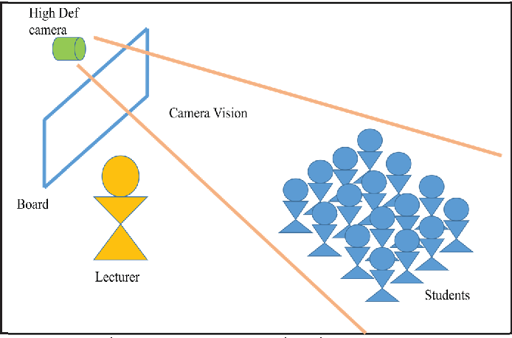

Figure 1Representation of the system

**1.2 Objective**

This project is primarily aimed at locating the faces of the students present in the class and then recognising those students by comparing their faces with the one’s present in database. Upon comparing these faces the system may recognise as to who were the students who attended the class. For the technique of face recognition is used.

The technique of Face Recognition works on the concept of nodal points. A human face has around 80 nodal points. These nodal points include features such as distance between the eyes or the distance between nose and lips.

The system that we have proposed would ease up the process of taking attendance which initially would have consumed a lot of time and effort. The system would capture the image of the students present in the classroom. Then it would identify the faces present in the frame and compare all those faces with the database of the registered students for that particular course. Once identified it would mark these students present in the excel sheet that is being generated in the background. The comparison of these faces will be done on the basis of nodal points. The algorithm that we used for facial recognition uses nodal points in a very effective manner because this algorithm works in many arrays of light condition, be it a well-lit or overly lit or even room with less lighting the algorithm is capable enough to recogniser the face.

The model will be aimed at reducing the time and effort for the faculty during lectures and make the process a bit more hassle free. Using this model, we also plan on reducing proxies or false attendance. The portal will be a dynamic one wherein it can display information of the enrolled students and even give the option of adding students into the database and automatically mark their attendance.

* 1. **Problem Statement**

The+iamount+iof+idata+iin+ieducational+ienvironment+ithat+iis+inow+imaintained+iin+ielectronic+iformat+ihas+iseen+ia+idramatic+iincrease+iand+ivast+iusage+iin recent time. This data may be in the form of texts which may be used for deep learning as well. But further we also wish to implement a model wherein the faculty won’t have to take attendance manually by calling out the names of students. Automation in this process would simply result into a lot of time saving. Manual job is the old way of taking attendance. But this strategy takes a lot of time and there are risks that the attendance will not be correctly marked. Fingerprint recognition is the second method. But for certain individuals, since it is also linked to criminal recognition, it is invasive. Another downside to fingerprint identification is that the dryness or debris of the finger's skin can cause errors. Iris identification is the other methodology for taking part. The downside of this approach is that it is often invasive and data storage takes a lot of memory.

In all the institutes for tracking the success of students, retaining attendance is very critical. In this regard, every institute has its own system. Some use the old paper or file-based approach to take part manually, and others have implemented automated attendance methods using certain biometric techniques. There are several automated approaches, i.e. biometric attendance, available for this reason. Both these strategies often waste time because learners need to make a queue on the scanning system to touch their thumb. For the automated participation of students in the classroom setting without student intervention, this device uses the facial recognition technique. Using a camera attached in the classroom, this attendance is captured by constantly recording student photographs, identifying the faces in pictures and matching the identified faces with the database and marking the attendance.

The machine consists of a camera that records and transfers to the image enhancement module the photographs of the students sitting in the classroom. Photos are improved in the image enhancement module so that matching can be done quickly. The picture comes into the Face Detection and Recognition modules after improvement, and then the attendance is marked in the database. In the Face archive, templates of face photographs of individual students are processed at the time of registration. All the faces are identified from the input image here and the algorithm compares them to the face database one by one. If any face is recognized, the attendance is labelled for various uses in the database from which anybody may view and use it. Teachers come to the class and only press a button to initiate the attendance process, and without all the intentions of students and teachers, the machine gets the attendance automatically. This system saves a lot of time for a teacher. The conventional approach had the faculty calling out our names and we just waiting for our turn thus wasting 10 minutes of a class that was supposed to be of 60min. Waving these 10min off is something that can be done if we use Face Recognition technique. These 10 minutes saved clubbed through a semester or an academic year sum out to be a lot and in this time the students can acquire a major chunk of knowledge which otherwise would have been left out just due to the fact that manual attendance had to be taken. Further the question that arises are:

* Which algorithm would prove to be the best?
* What could be the limitation in this system?
* How can we overcome these limitations?
  1. **Language and Software Requirements**

Language used is - PYTHON

Software Requirements:

* Software that supports .CSV format e.g. Microsoft Excel
* Visual Studio
* OpenCV
* Tkinter
  1. Hardware Requirements
* Intel i3 or above
* 4GB of RAM as the dataset used is of images so it will use resources.
* GPU for interpreting with the images and graphical representations.

**1.6 Deliverables**

At the end of this project our system will be efficient enough to recognize multiple students in the frame and after recognizing the student the attendance of student can be marked as present automatically as well as manually. Further the administrator would be able to login to the database and see the list of students who have been enrolled into his subject. In case a new face has to be added that too can be done through the interface itself where in the photo will be taken and then the model will be trained.

**CHAPTER 2**

LITERATURE SURVEY

* 1. **Literature Survey**

The objective of this chapter is to provide an insight into works and efforts that have already been put into the analysis and prediction of student and the theoretical framework of Educational Image Processing that has been a relevant and a hot topic for some years now due to increased changes and modernisation in the educational sectors in the recent years.

Various research studies have been done on the datamining process for education sector.

One of the key concepts for effective management of the coded knowledge is image processing. The CCTV is fixed at the entrance of the classroom in this method and is used to capture a picture of the student entering. The faces identified are stored in a database and are compared with existing images using the technique of Eigen faces.

[1]A 3D face recognition technique is used to determine whether the student image matches. If a match is identified, this image is processed for attendance management.. Doing this we can recognise the knowledge gaps between the work that has been done by the researchers previously and doing this would help us justify our work and our research questions and have a set of direction for our future work. The attendance will be labelled for the student picture matched for participation management and the details will be submitted to the server that manages the student's overall database. When the server receives the message of a student who is missing on that specific day it will send an SMS

to the parent of that particular student. The app is installed in a mobile phone to help boost the report functionality.

In[2], the writers suggested a method to avoid the pitfalls of the conventional system of manual attendance. This paper explains how face detection and recognition in real time can be useful for marking student attendance. The paper reveals an automated attendance system consisting of a camera mounted to capture photos in the classroom, accompanied by the identification of multiple faces. This system involves several measures, such as Student Face Database Formation, HOG features, Face Detection and Eye Detection, SVM Classifier, Comparison/Recognition, Attendance marking, etc. To achieve the desired results, algorithms such as Viola- Jones and HOG features are used along with the SVM classifier. There were certain limitations in the paper where the device could be susceptible to lighting. By using algorithms that may not be sensitive to lighting and lighting, the proposed system may remove this downside. The system used a camera with HD Resolution.

Formation of questions is an important step which has to be followed here to carry forward our project. Population, Intervention, Outcome and Context are the most critical factors for framing of research questions and they have been laid in the table below

Table 1 Criteria for question formation

|  |  |
| --- | --- |
| Criteria | Detail of Targeted Organization |
| Population | University, Engineering Institution (Pvt, Govt.), students |
| Intervention | Method used for predicting student progress and grades |
| Outcome | Accuracy of student prediction, finalise prediction technique |
| Context | University, Colleges and Schools (Pvt, Govt.) |

Searched Database: IEEE+iXplore,+iSpringer Link, ACM Digital library, Researchgate, Science

Direct other computer science journals. Searching sentences and keywords: Automated Attendance system, Application of Image Processing in education, Automated Attendance system using PCA, Automated Attendance system using LBP, Automated Attendance system using LBPH. Publication periods that were taken into consideration range from the year 2008 till January 2020. The types of text searched included documents, PDF, Full-length paper with abstract and keywords which may also include IEEE Xplore research papers.

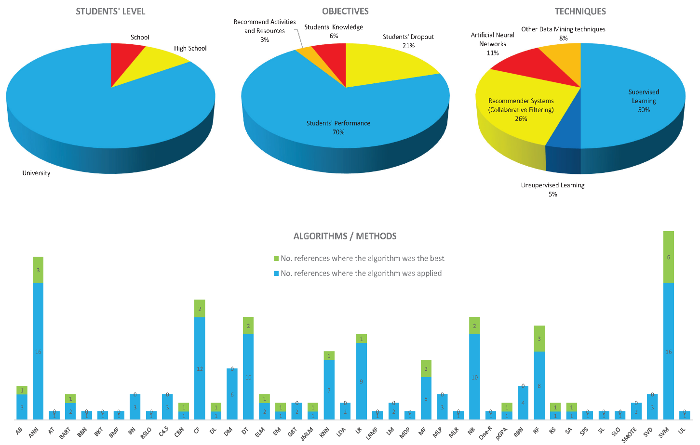

Figure 2 Statistics for Techniques, objectives and algorithm used

* 1. **Motivation**

In recent years we have seen a lot of advancements in various technologies, be it Machine Learning, Image Processing and Artificial Intelligence. These days the new smartphones coming in market are loaded with biometric as well as Face Unlock. This system is a proven effective manner of keeping our mobile safe.

This system can be expanded to an area of at least a class. With minor tweaking system can be used to differentiate and recognise each student sitting in the class and thus further it can be used to mark the attendance of students based on this facial recognition. This is a time efficient approach over the time consuming approach of calling out the names of each student and them marking them present individually. This system would minimize proxies by students as with proper training of the model it would be able to categorise actual person and photo of a person.

**CHAPTER 3**

IMPLEMENTATION

* 1. **Dataset Used**

The dataset used has been formed by using the images of people. For this problem statement the dataset that we used comprises of the students of my batch wherein the faces of students were marked separately by taking their pictures and along with this the classifier that we chose was LBPH therefore the dataset also includes side face images of students as this algorithm is capable enough to take the pictures of students and recognize them even by the side face. Therefore, for each student a total no of 71 pictures were taken which includes normal photos, photos of right side of their face and the photos of left side of their face.

This dataset therefore helps us to increase the accuracy of the model many folds and with the betterment in this dataset and introduction of faces of people in this dataset would be used to predict and also over the period of time increase the accuracy of the developed model.

The Dataset being stored is in the JPG format and the name being assigned is in the manner studentname_enrollmentno. Further this data is being stored in Student details and trainer.yml which further are used to interact with the dataset that we have made.

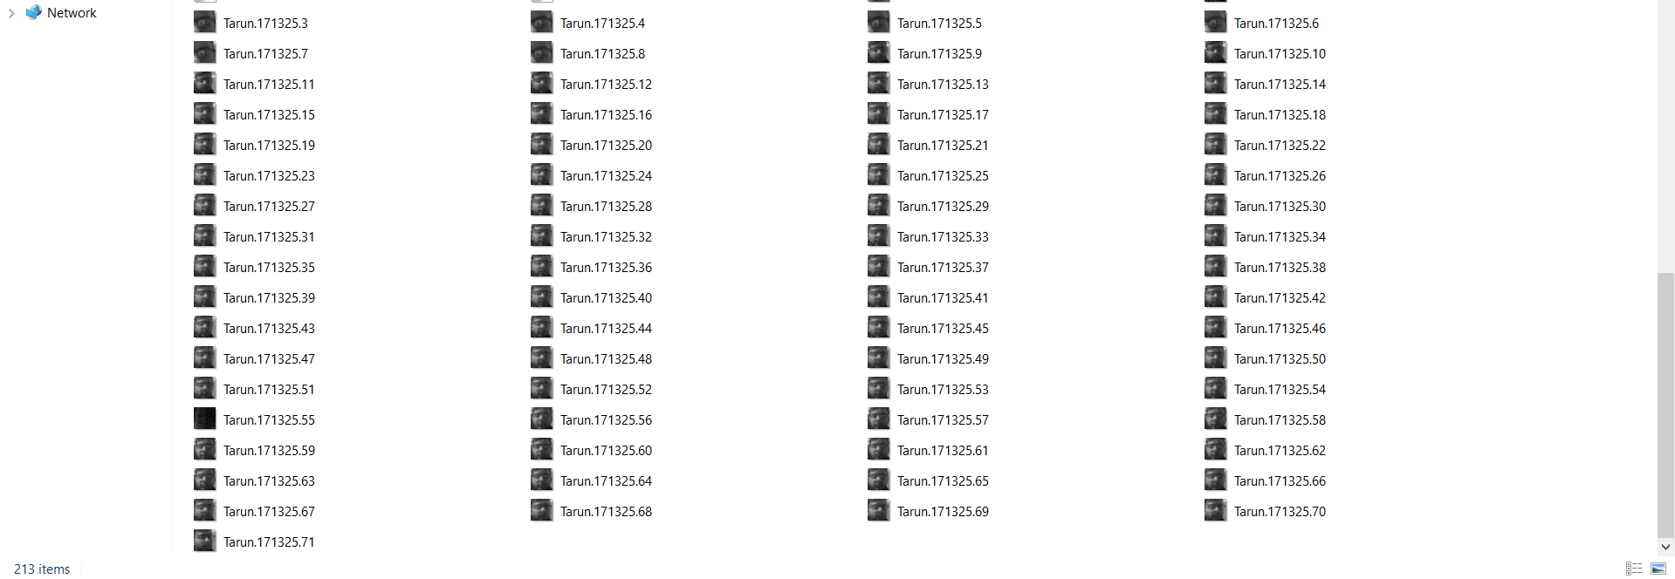

Figure 3Image Dataset

* 1. **Dataset Features**

A total of 80 features i.e the nodal points are present in the dataset and almost all these features enlisted to be used by the chosen classifier that is, LBPH we have come up with a proposition that the algorithm uses a set no of facial features and these features ought to be used for better classification thus requiring no changes. The dataset that we used has information of students with every student having his picture clicked 71 time. This number is set to 71 due to the fact that the system on which the model was being developed was unable to compute a much larger dataset that what has been made for now. The attributes and details of these attributes for both the .csv files. The method of face recognition is used to identify a person by using certain characteristics of that person and matching the digital image feature. Face, nose, skin, iris, hair, etc are the characteristics that are derived for facial recognition.

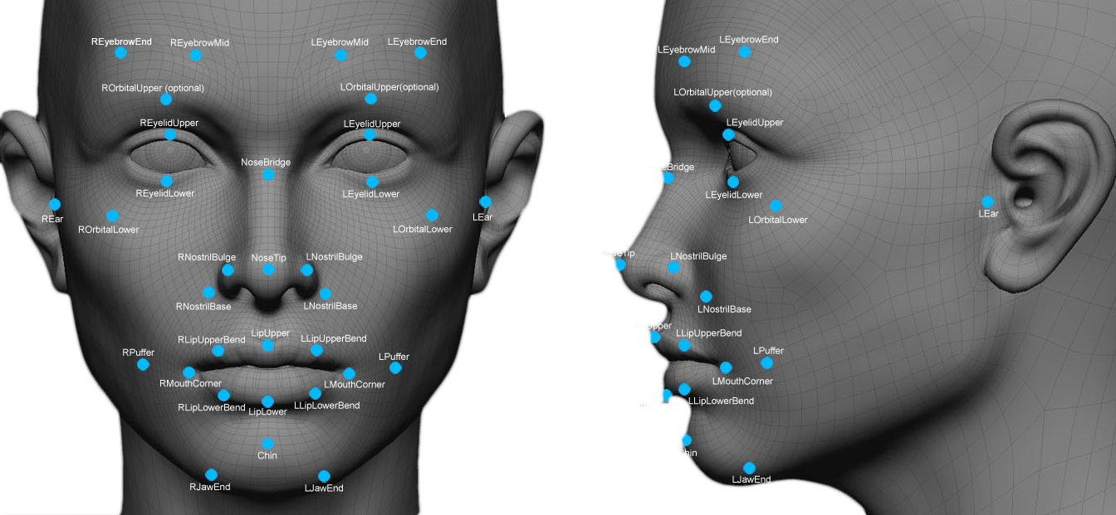

Figure 4 Nodlal Points



Figure 5Dataset Validation

* 1. 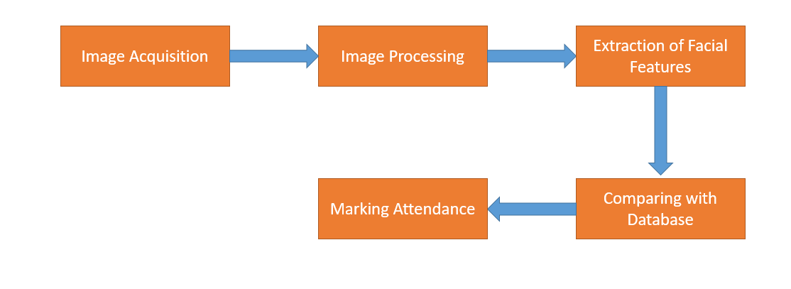 **Proposed System**

Figure 6 Proposed System

The dataset of composed of multiple images of the students. Each student is being captured 71 times that is, each student has these number of photos for the training dataset. This dataset will be compared with the real time picture of the students in the classroom and further the attendance would be marked based on this. After the images are clicked pre-processing is performed on these images wherein unwilling distortions are removed or in some cases features are improved. The image is converted into grayscale after which the extra part of background is removed. The simple reason of subtracting the background is that this would increase the accuracy. The images that are being processes have their features extracted and the cropped images that majorly contain face are stored separately for the purpose of comparisons. This approach is helpful once image sizes square measure giant and a reduced feature illustration is needed to quickly complete tasks like retrieval of the image and also the matching of the image. Image is represented as a compressed feature vector. The dimensionality of an image is reduced at the time of feature extraction.

The images have to go through the process of pre-processing along with face detection because until and unless the face is detected operations on images such as cropping or background subtraction cannot be conducted. The database of the students is used here as these need to be compared with the faces that are being detected in the class. When the model finds a match it automatically marks the attendance of the student as present.

* 1. **Image Processing**

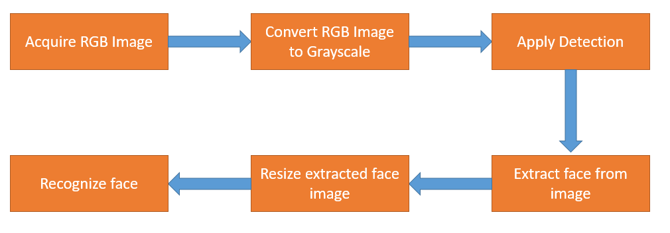

Figure 7Flow Control

In order to get an improved image or to retrieve any useful information from it, image processing is a method of transforming an image into a digital form and performing some operations on it. It is a type of signal dispensation in which an image is input, such as a video frame or picture, and an image or features associated with that image may be output.

Typically, the framework of image processing involves treating images as two-dimensional signals while applying methods of signal processing to them that are already set.

The steps involved here are:

1. The image is captured. This image is a coloured image and being coloured it may have a high opacity that tears up colours. This image this needs to be converted. It could be as simple as being given an image which is in digital form. The main task that needs to be achieved after this is scaling and conversion of image.
2. The RGB image captured is changed into Grayscale. The simple reason being that the issue of lighting is dealt with in grayscale and also the size of the image decreases.
3. Detection for the face is applied. The algorithm looks for the face from the image.
4. After the algorithm is able to locate the face the face must be extracted. The image needs to be enhanced. It is often used to remove certain secret information from an image and is subjective, among the easiest and most desirable in the field of image processing. The background here is subtracted. This too reduces the size of dataset with just focusing the features that are needed that is the nodal points of the face.
5. The extracted face image needs to be resized. Full size image won’t be of no use and would just increase the size of dataset.
   1. **Algorithms for Face Recognition**

Selection of apt algorithm for a problem statement is a very important and tedious task. Each classifier has its own set of advantages and disadvantages. For any particular project or research we try to figure out a classifier that provides us with the best possible accuracy as at the end what matters is how accurately our data is being accessed by our classifier and based on this accuracy we later on after training our classifier can get the right set of results.

The understated algorithms are the ones we tried and tested with our dataset and at the end had to select the one that had the best accuracy for our problem statement.

* + 1. **Principal Component Analysis :**

Principal Component Analysis (PCA) is a technique used for dimensionality reduction used in Image Processing. In Principal Component Analysis transformation is applied to the variables using which larger set of variables are reduced to a comparatively smaller set. In this technique the linear correlated variables are converted into uncorrelated variables as this tells us about the redundancy that can be reduced thus reducing the size of the image with minimum loss. The method helps in compression and preserve the data as much as possible.

Principal Component Analysis cannot be used for categorical data and in order to do so dummy variables need to be created. This algorithm has certain steps that are followed in order to perform the task. Firstly, the module and the image data are loaded. In the next step Data Exploration is done. After this Image Standardization is carried out. The variables must be consistent and for this the data should be in same format. In the next step PCA Transformation is done. After the transformation is done Eigen and vector values are computed. After this step we check as to if we were able to produce principal components successfully which would further result into better compression and less redundancy. After all these steps are completed 1D PCs are converted back into their original image shape.



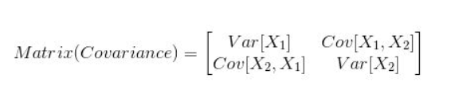

det( ƛI - A ) = 0

( ƛI - A )v = 0

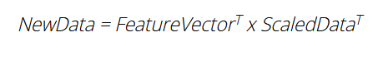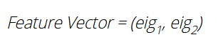

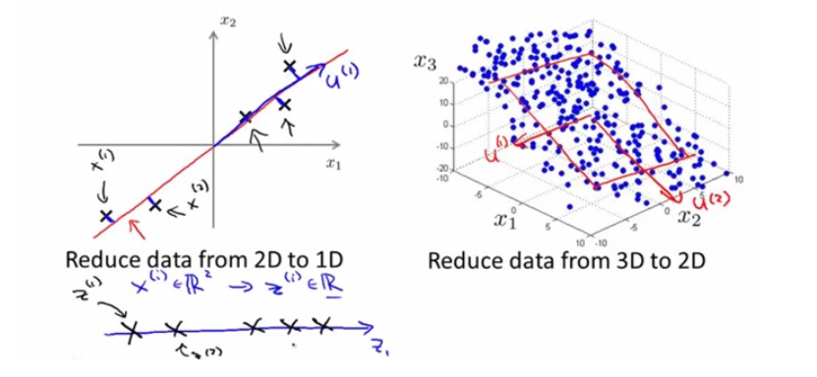

* + 1. **Local Binary Pattern:**

Local Binary Pattern (LBP) is a simple yet very efficient texture operator which labels the pixels of an image by thresholding the neighbourhood of each pixel and considers the result as a binary number. Local Binary Pattern is a set of circular neighbourhoods with the centred pixels lying in the middle. Grayscale images are the key here where localized texture patterns are described on the images. In Local Binary Pattern the concept of thresholding comes into play as this concept is used to get the LBP value on the circular pixels using the central pixels. These pixels lie in close proximity to each other. They have a binary weight assigned to them.

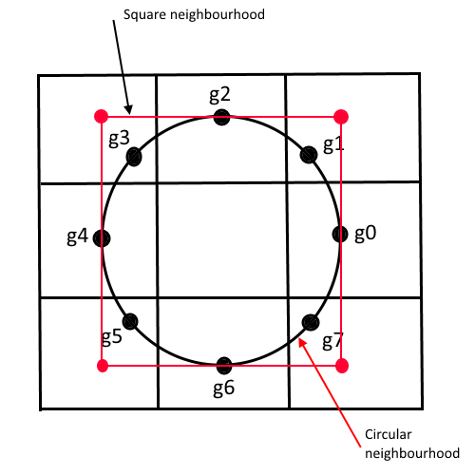

For the algorithm to implemented certain steps need to be followed. Firstly, the image that is will be fed as a dataset needs to be converted into grayscale due to a very simple reason because in case of a grayscale image the extra or low lighting condition does not hinder a lot whereas in case of RGB image extraction of facial features becomes difficult. After this implementations and conversions on the image are started. For every pixel in the image, a neighborhood is selected that surrounds the central pixel. The central pixel is selected and we further set it as a threshold for the neighboring pixels. If the value for adjacent pixel comes out to be greater than or equal to the value at center pixel the value would be marked as 1 in binary form and 0 is it is less. After this step the LBP vales are computed sequentially in counterclockwise manner.

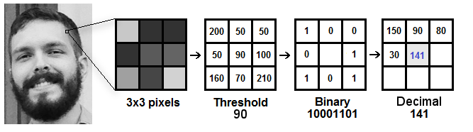

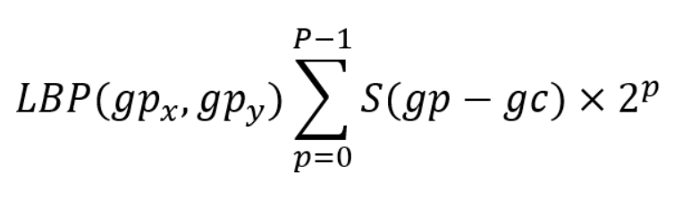

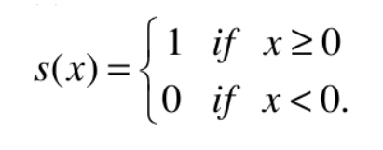

* + 1. **Local Binary Pattern Histogram:**

Local Binary Pattern Histogram is simply the histogram representing the number of occurrences of each LBP binary code in whole image. After obtaining histogram from each grid, they are combined to form a bigger histogram which represents the whole image.

LBPH is very efficient in face recognition. A face image can easily be mapped to a data vector using LBPH representation. For face recognition, histogram is created for each image in training dataset.

If a input image is given, histogram is created for that image using LBPH and then it is is compared with each histogram created during training, and the image with closest histogram is returned as output.

For comparing two histogram, euclidean distance, chi-square, absolute value can be used higher success rates when compared with other algorithms. As a result, it has found a wide usage in the areas such as identifying spam e-mails and Sentiment Analysis in social media analysis, to get review of a product.

This algorithm was used by us in order to test our dataset and the results that we got related to the accuracy and precision were used to compare with other algorithms so that we can use the best algorithm amongst all these for the required project.

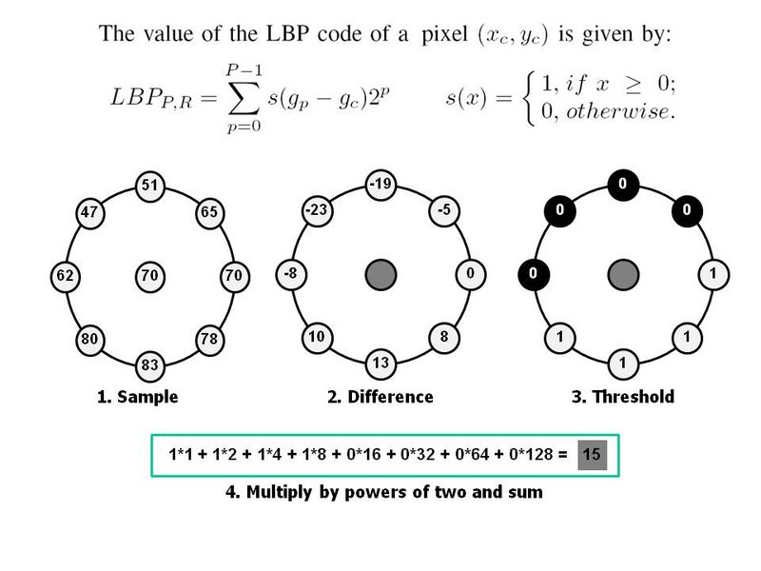

Figure 8Cyclic Representation of image values

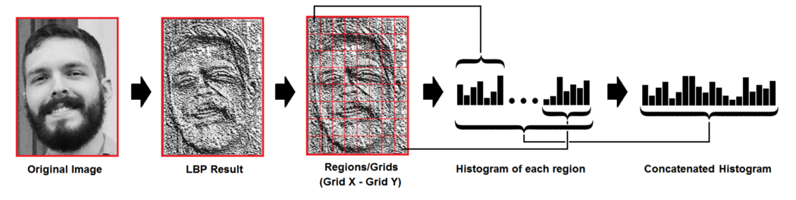

Figure 9 Histogram form of images



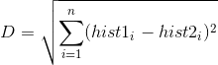

* 1. **User Interface**

It contains list of menu items which can be accessed by the faculty. These include the registration of students. This registration includes the name and enrolment no of the students. The Take Image option provided clicks the image and stores it in the .jpg format in the training image folder. Then upon clicking the Train Image button the algorithm will start working and train the model for that particular student in addition to the others that have been added to the model previously. We can check the registered students as well. The interface gives an option of Automatic as well as Manual attendance. The model stores the attendance results in an excel sheet by the name of the subject and the date and time of class.

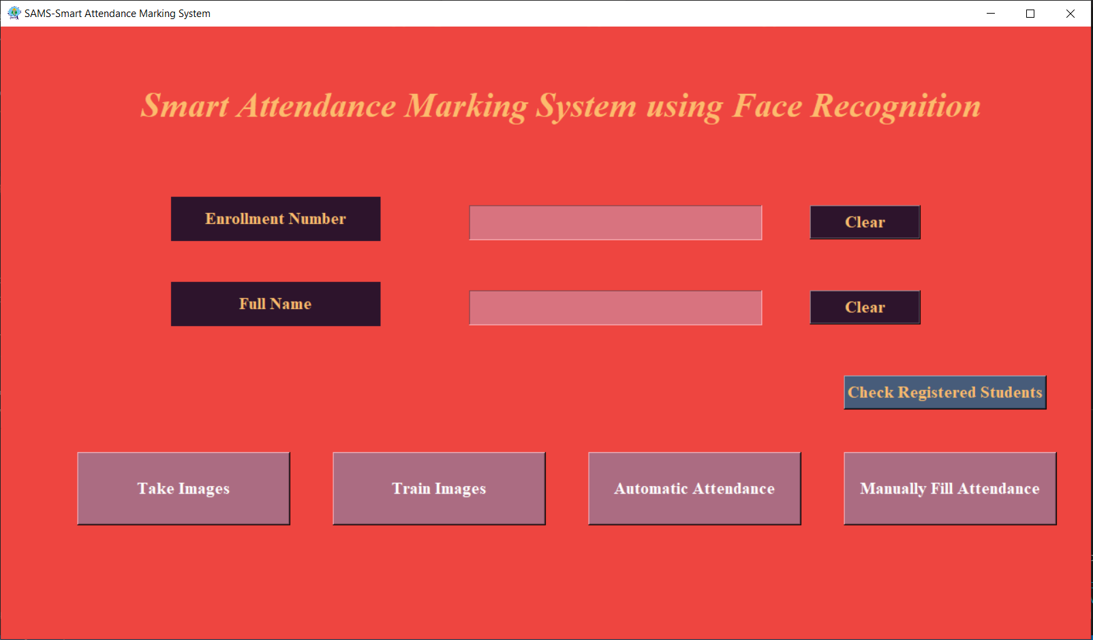

Figure 10User Interface of Model

* 1. **Accuracy of the Algorithms**

|  |  |  |
| --- | --- | --- |
| DM Classification Algorithms | Issue Faced | Summary |
| PCA | The recognition rate was lower than expected and was not suitable for times when lighting condition was low | HAAR classifier and computer vison was used for the purpose of face recognition |
| PCA and Eigenfaces | The validation was not done therefore once marked present the accuracy could be reduced | The usage of platforms was increased by the introduction of Eigen faces |
| LBP | The recognition rate was better that what PCA gave out but still low light was an issue. | HAAR classifier and computer vison was used for the purpose of face recognition |
| LBPH | The issues with LBPH were dealt here and also additionally the model could also recognise the side faces. | HAAR classifier and computer vison was used for the purpose of face recognition |

Table 2 Accuracy of Classifiers

* 1. **Flowchart**

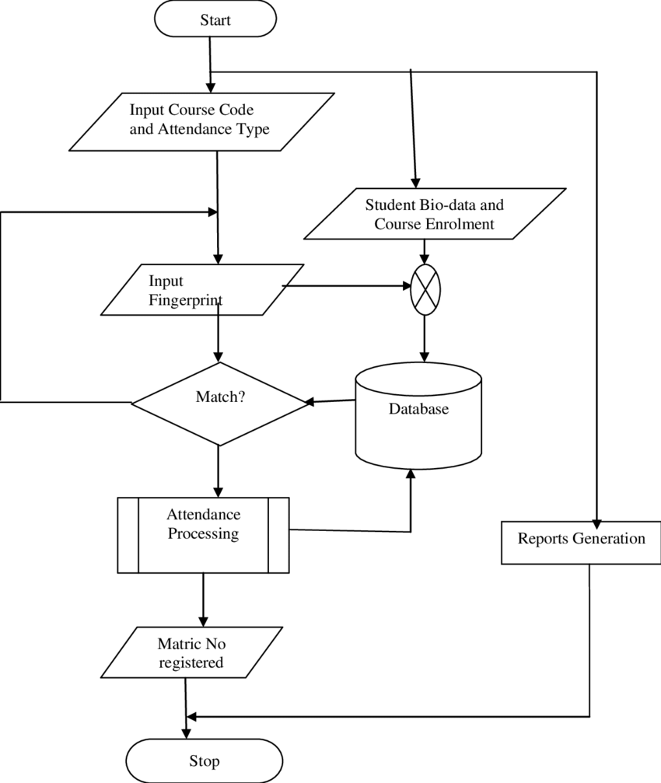

* 1. **Algorithm/Code**

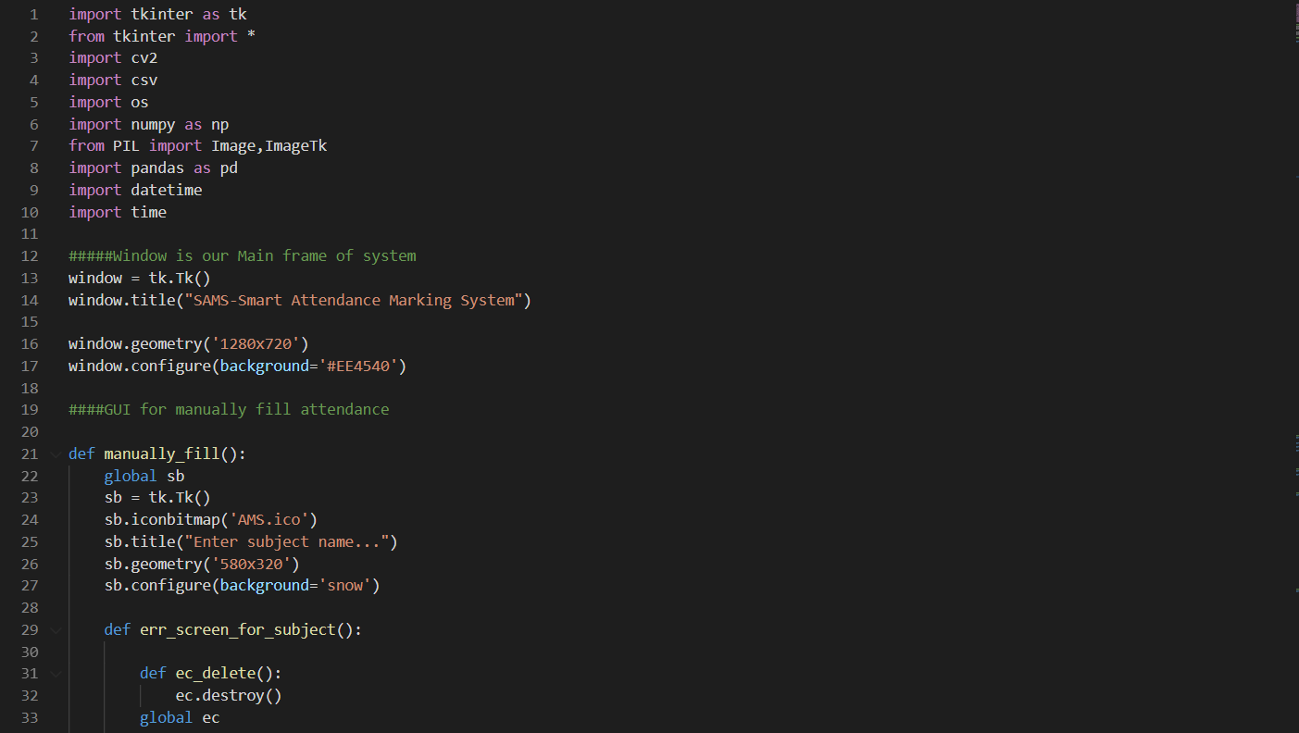

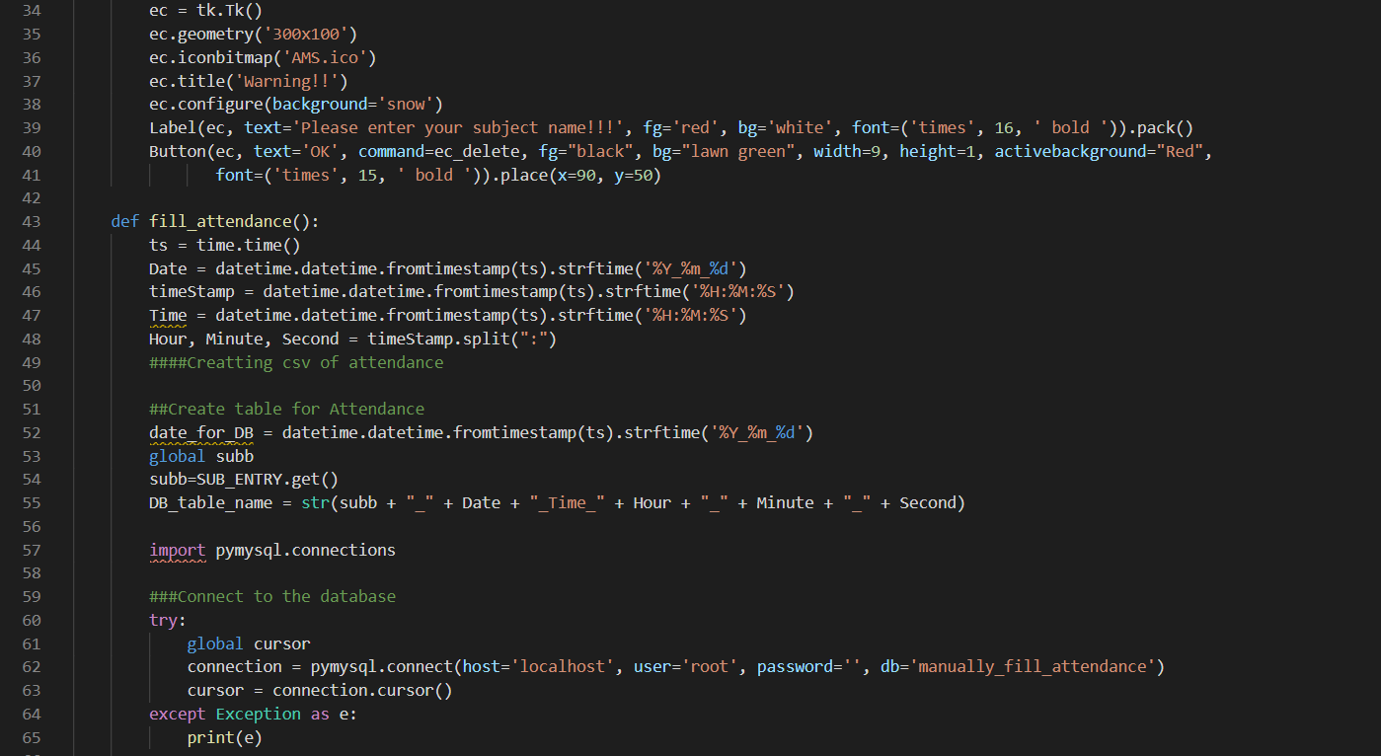

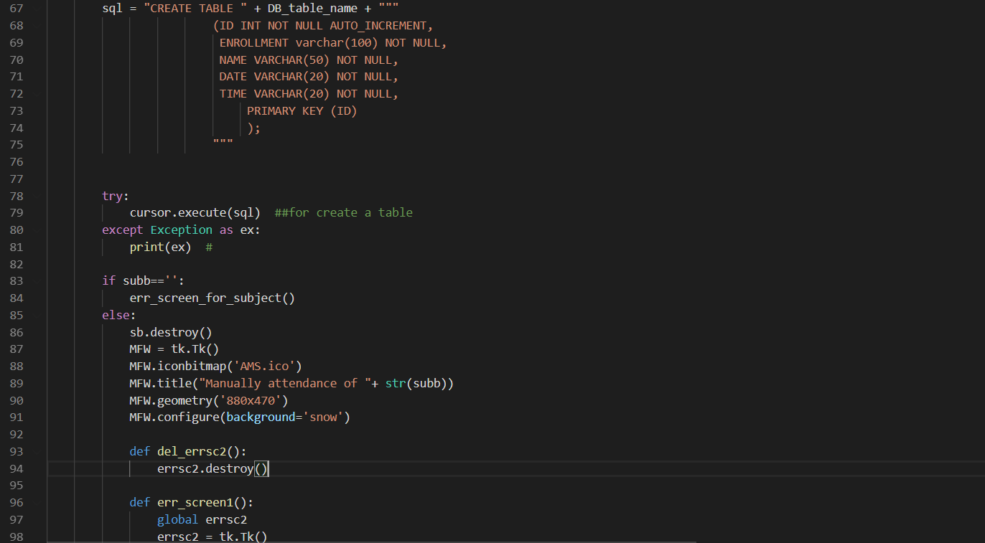

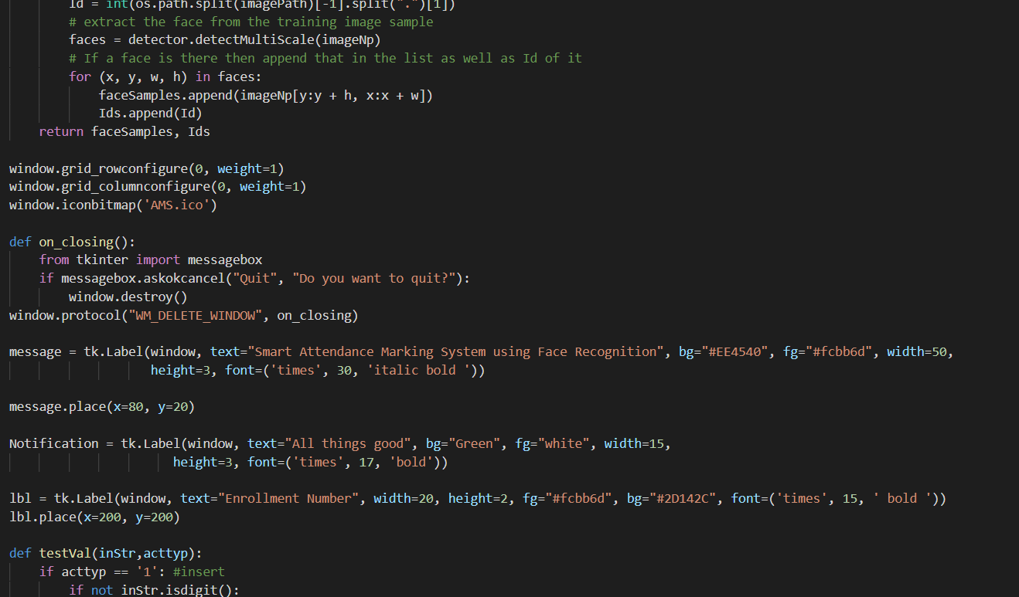

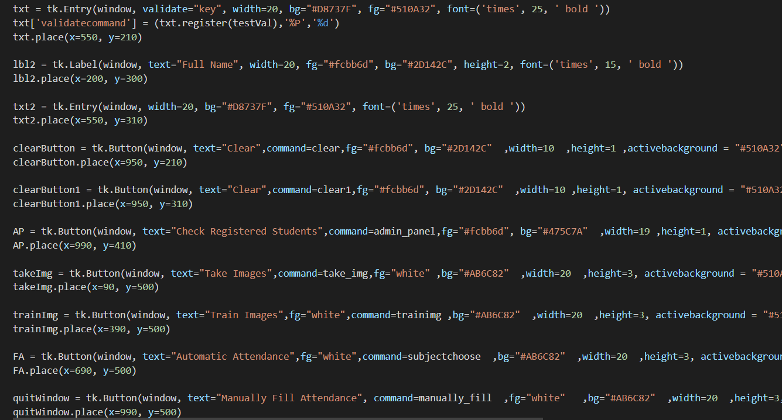

Figure 11GUI Code

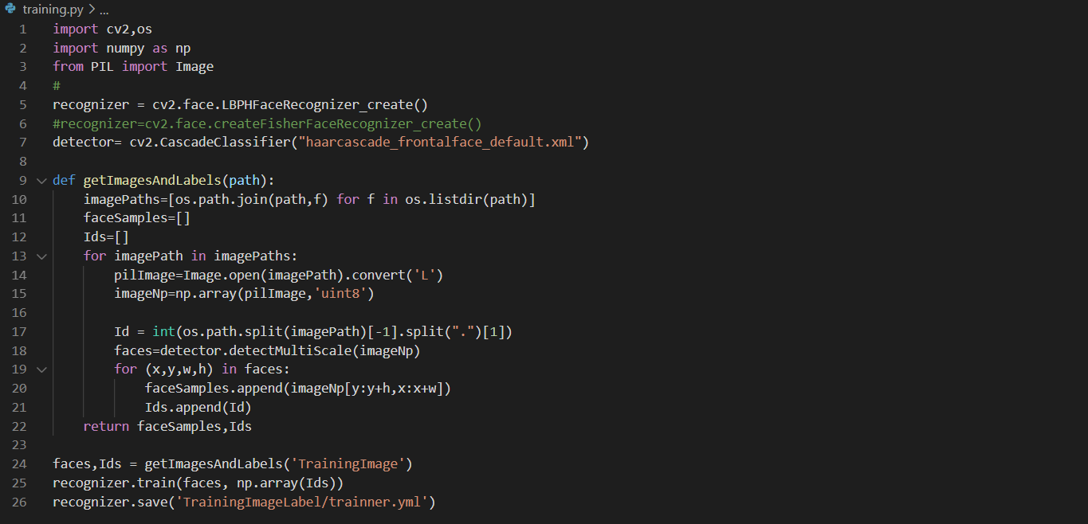

Figure 12Training code

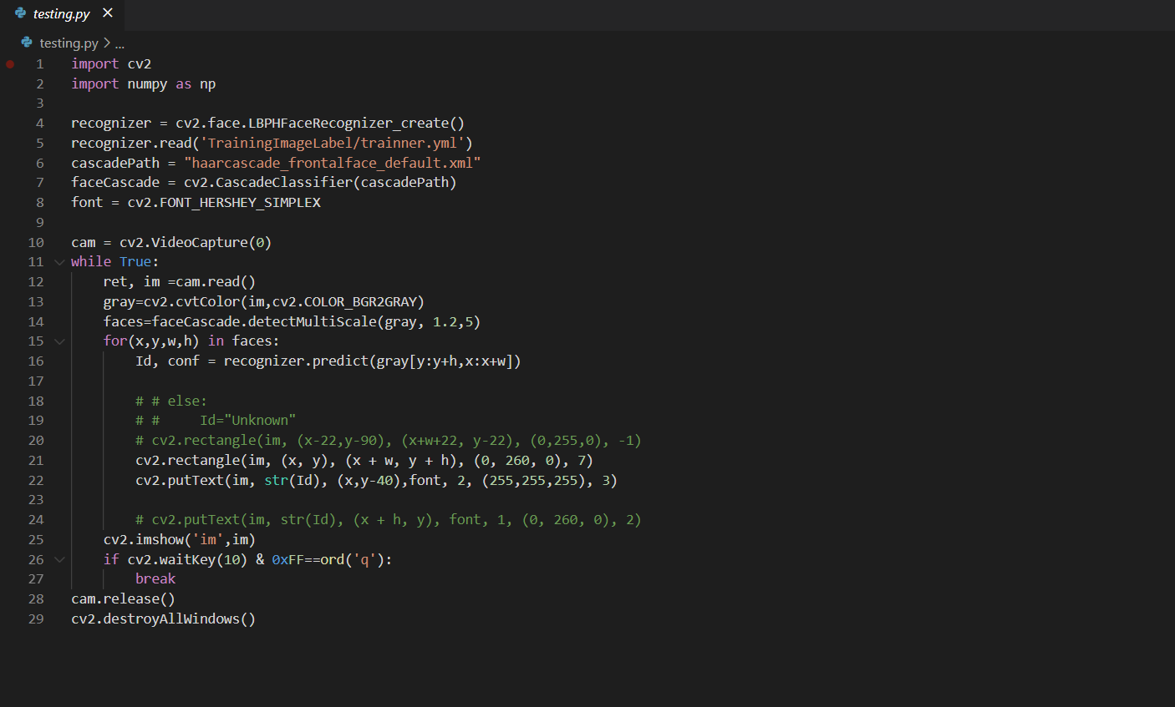

Figure 13Testing code

* 1. **Stages of Execution**

Firstly, we did test a number of classifiers with our dataset just to have an outlay to whether which classifier would work best with our problem. Accordingly, the classifier with best accuracy was chosen among all these. The accuracy was dependent on some major factors such as the lighting conditions or the distance from the camera. Based on this the algorithm was chosen.

The Graphical User Interface for the system was designed. This included addition of various features that could be added in this model. After this the work on the algorithm started. For this firstly the developed model was to be implemented because we used various algorithms to get an idea as to which algorithm would suite our needs. For this the steps that were followed were:

1. Image Acquisition
2. Image Processing
3. Extraction of Facial Features
4. Comparing with the database
5. Marking Attendance

Upon implementation of all these steps the different algorithms were tested and after that we could come to a conclusion that the proposed system would work best with the LBPH algorithm. After this all this was compiled with the User Interface that was designed using Tkinter. The model made has a good accuracy for prediction and may give good results.

**CHAPTER 4**

RESULTS

* 1. **Results Achieved**

Here, in this section we are discussing the results that we have garnered from all the previous analysis that we have been doing. Here the Jaypee University of Information Technology students' database or training set has been developed. The database includes photos of students, with seventy-one images for each student. Thus, the overall picture is equivalent to 90. Below the training set is displayed.

Each image is 92-112 px, as stated earlier. Photos, which are now worked on are different in the test collection, i.e. they are not taken from the database. The test set can be shown as follows in the figure:

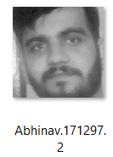 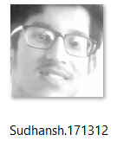 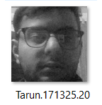

The input image is processed when an input image is presented that is not present in the database and the best matching is considered to be the recognised image. There is a diagram indicating the experimental outcome. Where the image acknowledged is a database image and the image acknowledged is Tarun-171325, which is displayed in the Tkinter interface.

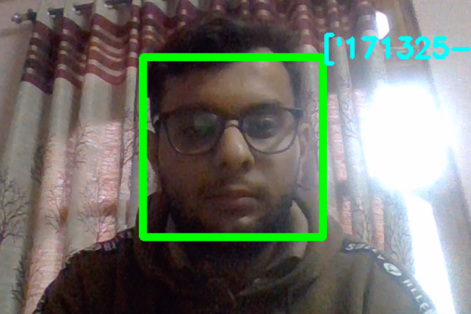

Figure 14Student Identification

* 1. **Conclusion**

The approach of deriving and using data from research published previously and the previous editions of the same course may have raised some doubts regarding the approach and whether is it viable enough that we compare the outcomes for the courses. However, the extents to which our prediction models discussed in this report have proven out to be convincing enough to prove the point that this approach is just not only possible but gives out a much better output than expected. The performance of the models is in fact expected to improve Acknowledgment of pictures applies to frameworks that perceive pictures of locales, symbols, people, ancient rarities, structures, and numerous different factors. Clients use cell phones, interpersonal organizations, and online journals to trade huge volumes of information. Moreover, PDAs fitted with cameras are adding to the advancement of computerized photos and recordings that are boundless. Organizations are utilizing the tremendous measure of advanced information to give more and more intelligent contributions to the clients utilizing it. Picture acknowledgment is a piece of PC vision and a cycle to distinguish and identify an item or property in an advanced video or picture. PC vision is a more extensive term which incorporates strategies for social occasion, preparing and examining information from this present reality. The information is high-dimensional and produces mathematical or emblematic data as choices. Aside from picture acknowledgment, PC vision additionally incorporates occasion discovery, object acknowledgment, learning, picture remaking and video following.

An image is deciphered by the natural eye as an assortment of prompts that are handled in the mind by the visual cortex. This outcome in a dynamic scene experience, associated with thoughts and antiques that are recorded in one's brain. Picture identification endeavours to imitate this system. An image is deciphered by the gadget as either a raster or a vector picture. Raster pictures are a progression of shading commented on polygons with particular mathematical qualities for colors, while vector pictures are a progression of pixels. Therefore, it has the wider scope.

The implementation of this model has a very wide prospect and with changes and betterment over the course this model will be capable enough to recognise the students in a more precise and accurate manner. The LBPH algorithm used here has proved out to be the most accurate approach for us so far and with better models that may come out in future this system may be bettered over time.

* 1. **Limitations**

The fact that the dataset has to be kept limited is a challenge. With the increased dataset the model requires more computational power and to do so the system needs to have better specifications be it the RAM of the computer or the processor or as a matter of fact even the GPU also needs to have a good computational power. Also upon introducing this at a classroom level firstly the camera installed in the front should have a good resolution so that the system can clearly identify the faces of the students. One of the major limitations in this version of the project is that for now the model cannot distinguish between a picture and a actual person sitting. This system may mark attendance as present if shown the picture of the person provided that the camera is able to recognize that person from that distance Further this limitation will be dealt with in the next version of this project. A better dataset too will be used once the issue of computational power is dealt with.

* 1. **Future Work**

For now, the Graphical User Interface that we are using for the the project is quite basic one and with a bit more experience with Tkinter or some other framework the GUI of the application will be designed as a more appealing one. Advances in picture acknowledgment and man-made brainpower will incorporate verbalized requests, anticipating government information needs, deciphering dialects, distinguishing and checking people and articles, diagnosing clinical issues, directing a medical procedure, reinventing human DNA deformities, and driving all methods of transport naturally. The possibility of calculation will go past as far as possible with expanding strength and unpredictability of advanced registering, and picture handling innovations can advance later on and the visual framework will

The size of the dataset will be increased for a much better accuracy once the issue of computational power is dealt with and upon doing so the model would be able to address the limitations that are being faced for now.

The current addition that can be made is that the model extracts the names and grades of students and notify the teacher, the student and his parents who are at risk of either failing a subject or failing in a class so that appropriate measures can be taken at the right time before it is too late without the need of human intervention.

**REFERENCES**

1. A. Ahmedi and S. Nandyal, “An Automatic Attendance System Using Image processing,” pp. 1–8, 2015.
2. V. Shehu and A. Dika, “Using real time computer vision algorithms in automatic attendance management systems,” Inf. Technol. Interfaces (ITI), 2010 32nd Int. Conf., pp. 397–402, 2010.
3. J. Joseph and K. P. Zacharia, “Automatic Attendance Management System Using Face Recognition,” Int. J. Sci. Res., vol. 2, no. 11, pp.327–330, 2013.
4. J. Kanti and A. Papola, “Smart Attendance using Face Recognition with Percentage Analyzer,” vol. 3, no. 6, pp. 7321–7324, 2014.
5. T. H. Le, “Applying Artificial Neural Networks for Face Recognition,” Adv. Artif. Neural Syst., 2011.
6. P. Mehta, “An Efficient Attendance Management Sytem based on Face Recognition using Matlab and Raspberry Pi 2,” Int. J. Eng. Technol. Sci. Res. IJETSR, vol. 3, no. 5, pp. 71–78, 2016.
7. S. Jeng, H. Y. M. Liao, C. C. Han, M. Y. Chern, and Y. T. Liu, “Facial feature detection using geometrical face model: An efficient approach,” Pattern Recognit., vol. 31, no. 3, pp. 273–282, 1998.
8. P. N. Belhumeur, J. P. Hespanha, and D. J. Kriegman, “Eigenfaces vs. fisherfaces: Recognition using class specific linear projection,” IEEE Trans. Pattern Anal. Mach. Intell., 1997..
9. F. Ibikunle, Agbetuvi F. and Ukpere G. “Face Recognition Using Line Edge Mapping Approach.”American Journal of Electrical and Electronic Engineering 1.3(2013): 52-59.
10. K. Wong, H. Law, and P. Tsang, “A System for RecognisingHuman Faces,” Proc. ICASSP, pp. 1,638-1,642, 1989.
11. V. Govindaraju, D.B. Sher, R. Srihari, and S.N. Srihari, “Locating Human Faces in Newspaper Photographs,” Proc. CVPR 89, pp. 549-554; 1989.
12. N. Dalal, B. Triggs “Histograms of oriented gradientsfor Human Detection”, IEEE Computer Society
13. Conference on Computer Vision and PatternRecognition, Vol. 1, 2005, pp. 886–893.Modern Face Recognition with Deep learning.Website Reference:https://medium.com/@ageitgey/machine-learning-is-fun-part-4-modern-face-recognitionwith-deep-learning.
14. W. Zhao, R. Chellappa, P. J. Phillips, A. Rosenfeld, “Face Recognition: A Literature Survey.” ACM
15. Computing Surveys, 2003, vol. 35, no. 4, pp. 399-458. Gentleman, R.; Carey, V.J. Unsupervised Machine Learning. In Bioconductor Case Studies; Springer: New York, NY, USA, 2008; pp. 137–157.
16. Bobadilla, J.; Ortega, F.; Hernando, A.; Gutiérrez, A. Recommender systems survey. Knowl. Based Syst. **2013**, 46, 109–132.
17. Rapid Miner tool at <https://rapidminer.com/>
18. K. J., & Liu, N. (1992). A machine learning method for generation of a neural network architecture: A continuous ID3 algorithm. Neural Networks, IEEE Transactions on, 3(2), 280-291.
19. Yohei KAWAGUCHI, Tetsuo SHOJI, Weijane LIN, Koh KAKUSHO, Michihiko MINOH, Face Recognition-based Lecture Attendance System,
20. Department of Intelligence Science and Technology, Graduate School of Informatics, Kyoto University Academic Center for Computing and Media Studies, Kyoto University.
21. AjinkyaPatil, MrudangShukla, “Implementation of Classroom Attendance System Based on Face Recognition in class” International Journal of Advances in Engineering & Technology.
22. Mahalakshmi. R, Manjula. M, Saranya. S, Vaishnavi. P, Shalini. J and Arasa Kumar ,”Intrusion Detection by Facial Recognition using CCTV Cameras with Video Management System” International Journal of Advanced Electrical and Electronics Engineering (IJAEEE).
23. Naveed Khan Balcoh, M. HaroonYousaf, Waqar Ahmad and M. IramBaig, ”Algorithm for Efficient Attendance Management: Face Recognition based approach” International Journal of Computer Science Issues(IJCSI), , Vol. 9, Issue 4, No 1, July 2012.
24. Muhammad Fuzai, Hafiz Muhammad FahadNouman, Muhammad Omer Mushtaq, BinishRaza, AwaisTayyab, Muhammad WaqasTalib, “Face Detection System for Attendance of Class’ Students” , International journal of Multidisciplinary Sciences, Vol. 5, No. 4, April 2014.
25. AalamGumber, NavneetKaur , “Face Recognition Based Automated Attendance Management System using Principal Component Analysis” , International Journal of Science and Research (IJSR) , Vol 4, Issue 6, June 2015.
26. SeemaVerma, Prof.SonuAgrawal, A Study on “A Soft Biometric Approach: Face Recognition”, International Journal of Advanced Research in Computer Science and Software Engineering, Vol 3, Issue 3, March 2013. Alexander Gorman Santa Clara University, “CCTV Facial Recognition Analysis”, COEN 150 Project.